Hardware Design Final Project

**FPCAT – Battle Cat on FPGA**

Team 01

112062122 Chia Chin Hsieh 112062144 Sheng Wei Fan

Table of Contents:

1. Introduction 2

1.1 Motivation 2

1.2 Overview 2

2. Game Interface and Workflow 2

2.1 Start and Menu Scene 2

2.2 Play Scene 2

2.3 Win and Lose Scene 2

3. Game Material Design (Johnny) 2

3.1 Character Design 2

3.2 Stage Design 2

4. Game Engine 2

4.1 Storage Protocols 2

4.2 Character FSM 2

4.3 Game State FSM 2

5. Graphics Rendering 2

5.1 Rendering Module Architecture 2

5.2 Layer Implementation 3

5.2.1 Statis Objects 3

5.2.2 Characters 3

6. Conclusion 3

6.1 Gameplay Demonstration 3

6.2 Comparison with Original Game 3

6.3 What We Learned 3

A. Appendix 3

A.1 Contribution 3

A.2 Python Tool - PNG to COE 3

# 1. Introduction

## 1.1 Motivation

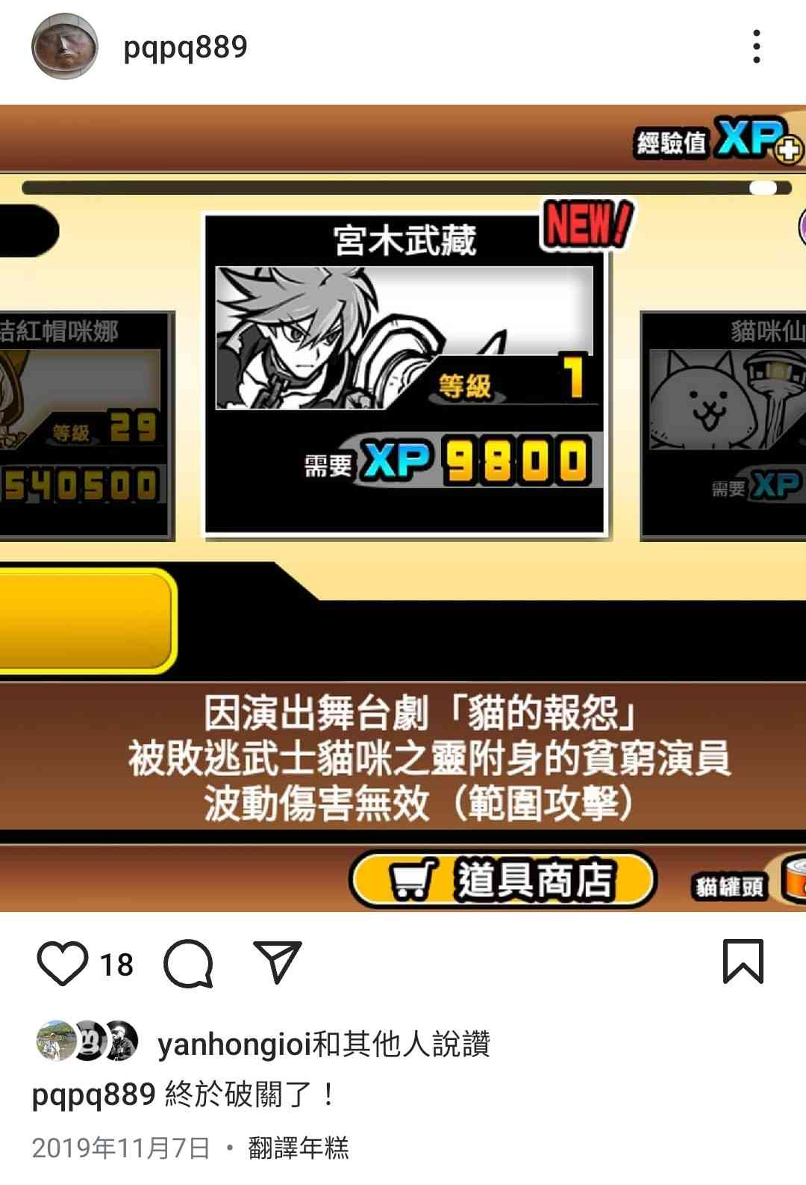The Battle Cats has been my favorite mobile game since I was in elementary school.

▲ Figure 1.1: An Instagram post of Chia Chin from 5 years ago

The stage and character designs are absolutely top-tier, even by today's standards. To share the fun of playing The Battle Cats with more people, we plan to create our own version of the game using FPGA. By showcasing this project on our GitHub accounts, we hope to demonstrate the game's appeal.

## 1.2 Overview

Our inspiration for the name "FPCAT" came from the integration of "FPGA" and "CAT". Our game requires players to use the mouse to operate. For screen signal transmission, we use VGA standard. The game begins with a **start scene**. After pressing the **start button**, the game transitions to the **menu scene**. each with designated enemies assigned to it.

In the **game scene**, players will have access to buttons for **cats**, **tower**, **purse**, and **pulse** (operated via an FPGA button). To **summon cats**, players must accumulate enough money, which can be earned over time. The **tower** can emit air cannon after it finishes charging. Players can also spend money to expand the **purse capacity** andspeed up the accumulation of money.

The goal is to destroy the enemy tower using the player's cats. If the player's cats succeed, the player wins. If the enemy destroys the player's tower, the player loses.

After triggering the **win scene** or **lose scene**, players can return to the **start scene** by clicking the mouse.

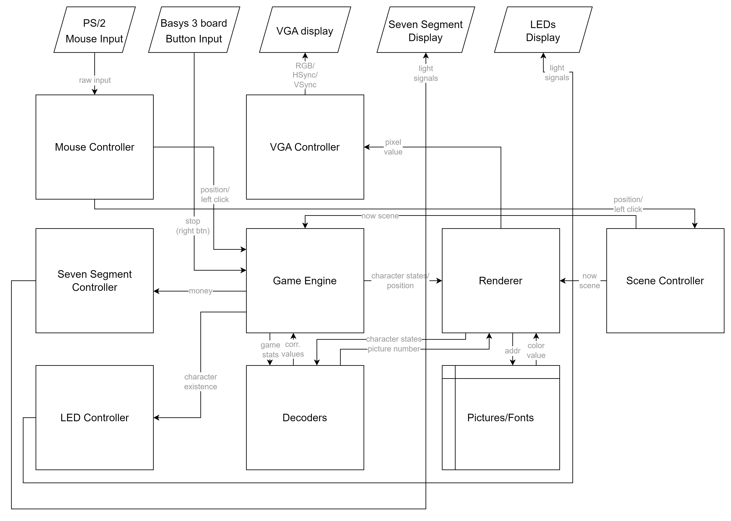

▲ Figure 1.2.1: Abstract module structure diagram

# Figure 1.2.1 shows the module structure and relationships within our project. This is a brief overview, with details discussed in the following chapters. For example, the renderer consists of four smaller modules: Render_Start, Render_Menu, Render_Play, and Render_WinLose. Each renderer computes its own color code independently. This is why it needs to take input from the scene controller's output. The details will be covered in Chapter 5.

# As for the Game Engine, we have represented it as a single block in the diagram. However, it is one of the most complex components we have implemented. It requires four different clocks and multiple signals to function properly. Additionally, it manages various gameplay elements, such as character states and game stats updates. Therefore, designing robust FSMs (Finite State Machines) is critical. We will elaborate on this in Chapter 4.

# Finally, we have added some thoughtful touches to the picture and font components, which will be discussed in Chapter 3.

# 2. Game Scene Architecture and Implementation Details

This chapter introduces our game's scene design and its detailed components. The following sections will explain our implementation methods, challenges we encountered during development, and how we solved these problems.

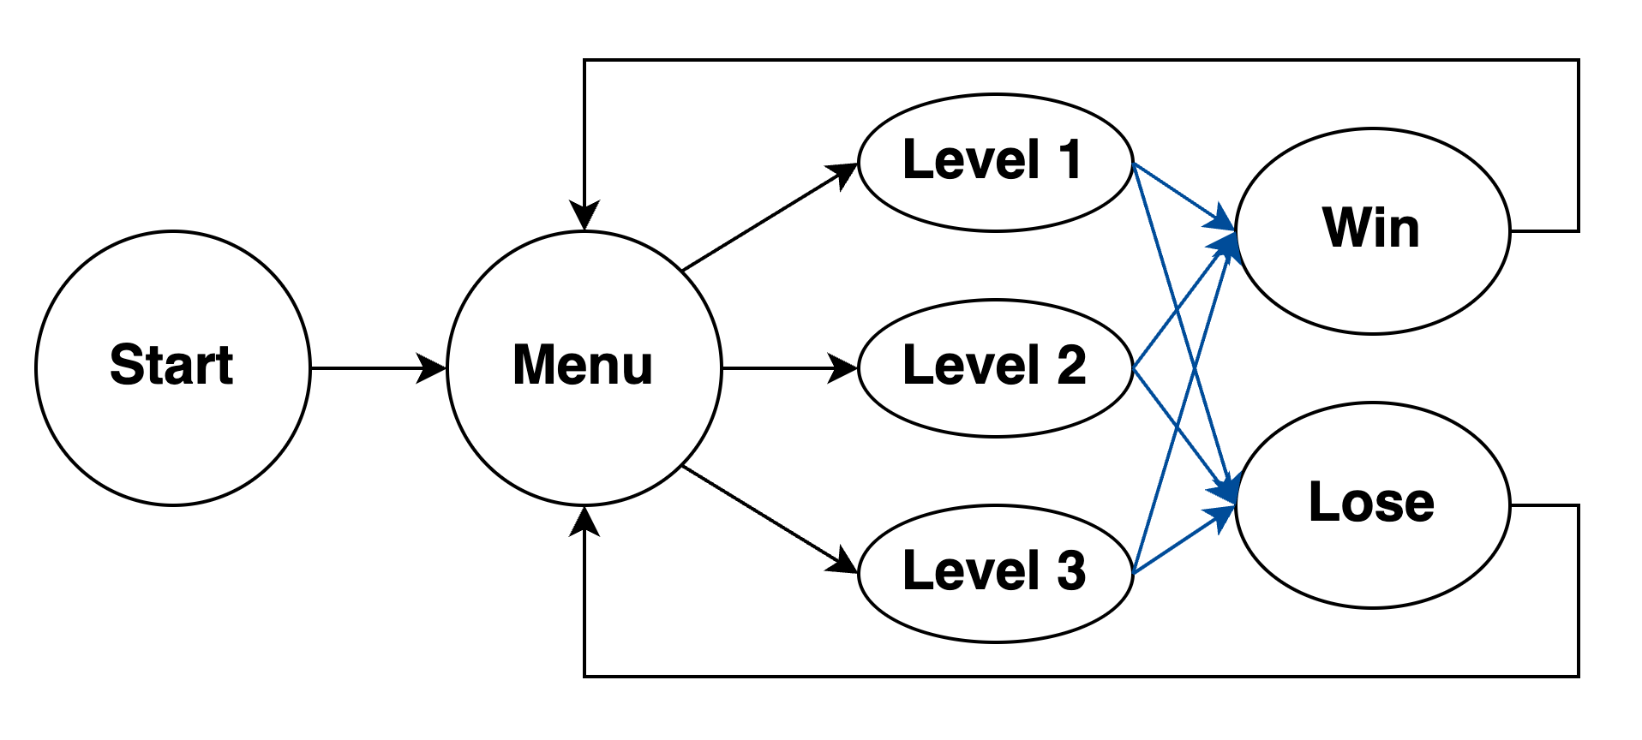First, here is our scene's FSM (Finite State Machine):

▲ Figure 2.1: Scene's FSM

The scene transitions marked in blue are the only ones triggered by the game engine itself, while all other transitions are initiated through button interactions. All mouse click detection implementations include **Debounce** and **One Pulse** mechanisms to ensure reliable input processing. For consistency, we used the clk_25MHz for these detections, which is the same clock signal used for VGA output and scene transitions.

## 2.1 Start and Menu Scene

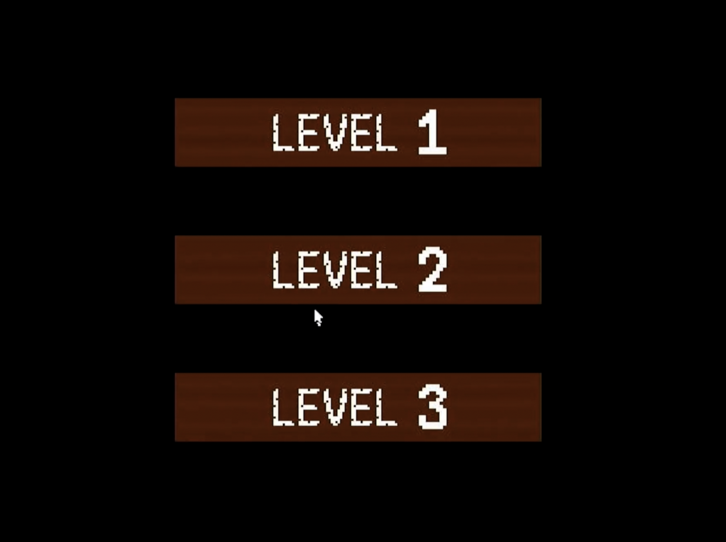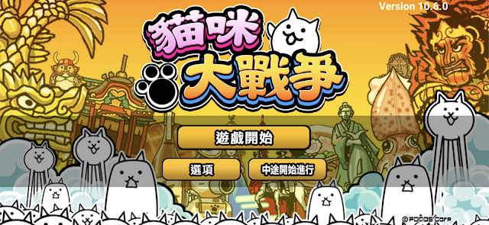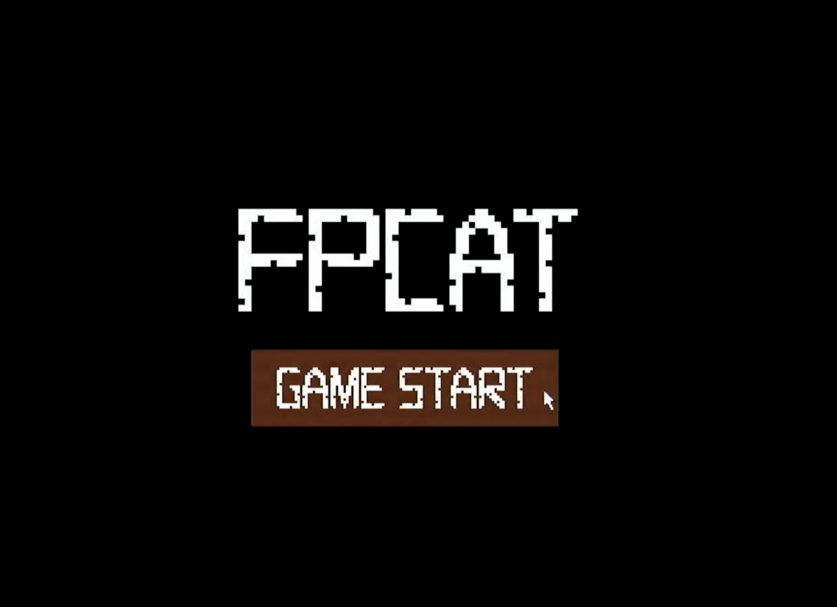We designed separate Start Scene and Menu Scene components based on our reference game Battle Cat, which features an initial game start button before entering the main menu. We decided to keep this design element as it provides a clear game entry sequence for players.

▲ Figure 2.2: Screenshot of Start and Menu Scene of ours and Battle Cat

Additionally, both scenes feature interactive buttons with hover effects - when the mouse cursor hovers over a button, its color changes to provide visual feedback to the player.

## 2.2 Play Scene

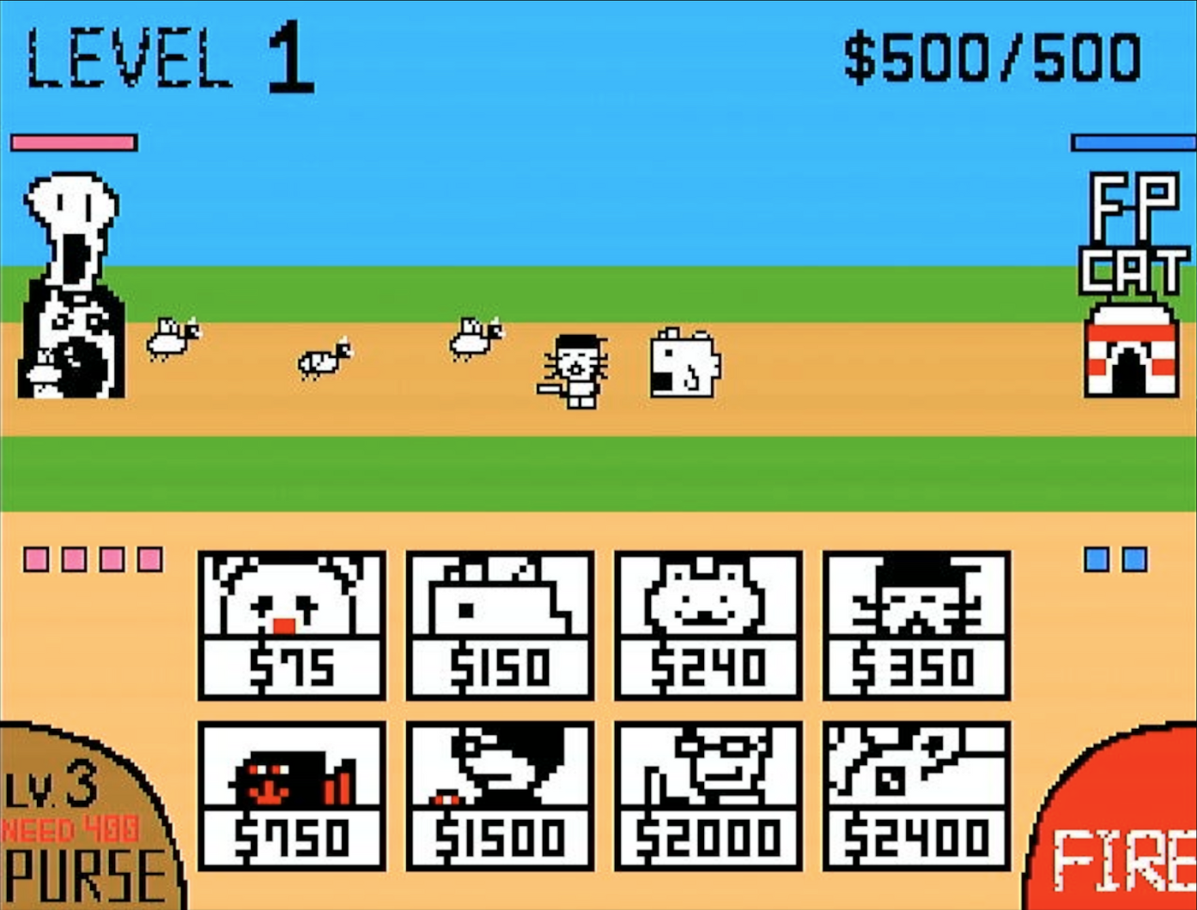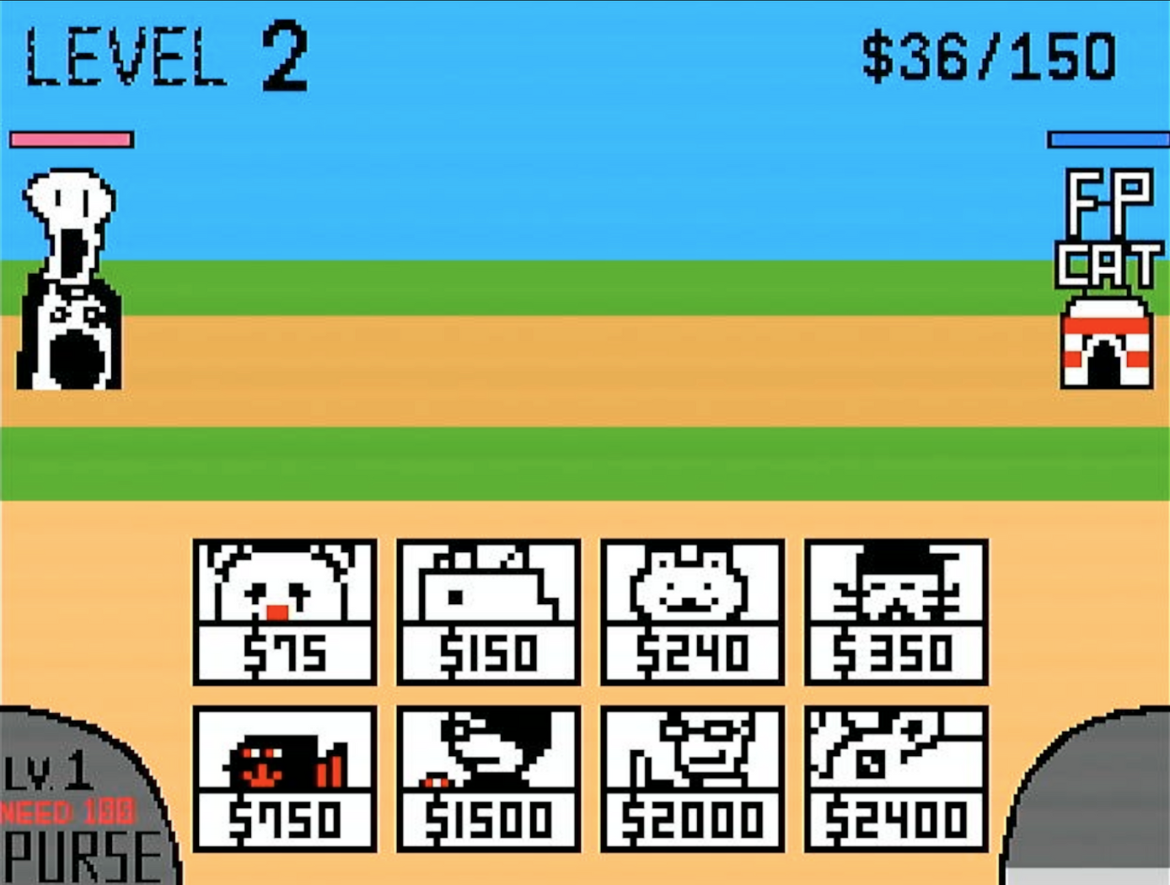Below is our game interface. We will explain each implemented feature in detail.

▲ Figure 2.3: Screenshot of Play Scene

* The Stage number is displayed in the top-left corner, indicating the current level.
* The top-right corner shows both our current money and maximum money capacity.
* In the bottom-left corner is the purse upgrade button. The Purse Level affects both the money generation rate and the maximum money capacity. The button appears gray when there's insufficient money for an upgrade and brown when an upgrade is available. The button displays both the current level and the cost for the next upgrade. The current money will also be displayed on Seven Segment Display.
* The bottom-right features the tower firing button. When fully charged, it shows a red "ready-to-fire" state. After firing, it turns dark gray and gradually transitions to light gray in segments as it recharges. This charging mechanism pays homage to the original Battle Cat game.
* Our tower is positioned on the right side with its HP displayed in blue, while the enemy tower is on the left with HP shown in red.
* The character deployment buttons are located at the bottom of the screen. Unit deployment is only triggered if sufficient money is available. When a unit is deployed, money is deducted and a cooldown effect appears on the button to prevent rapid consecutive deployments of the same character.
* Enemy unit deployment follows a pre-designed Enemy Queuing system, which will be detailed in Chapter 3.2.
* The red and blue little blocks on the sides of the screen indicate the current number of enemy and army (our cats) on the battlefield respectively (this information is simultaneously displayed on the FPGA's LED display). Both sides are limited to a maximum of 8 units on the field at any time. When this limit is reached, no additional units can be deployed. These frames serve as visual indicators, flashing when the 8-unit limit is reached to alert players that they cannot deploy more units, or that enemy unit deployment has been temporarily paused. When one or more enemy units are defeated, multiple new enemy units may be spawned simultaneously, potentially creating challenging combat situations.
* The battle between both sides takes place on a one-dimensional line. However, to prevent complete overlap of all unit layers during multiple-unit combat, units are randomly offset upon generation. All attack and detection calculations remain one-dimensional. This mechanism aligns with the original game Battle Cat.

## 2.3 Win and Lose Scene

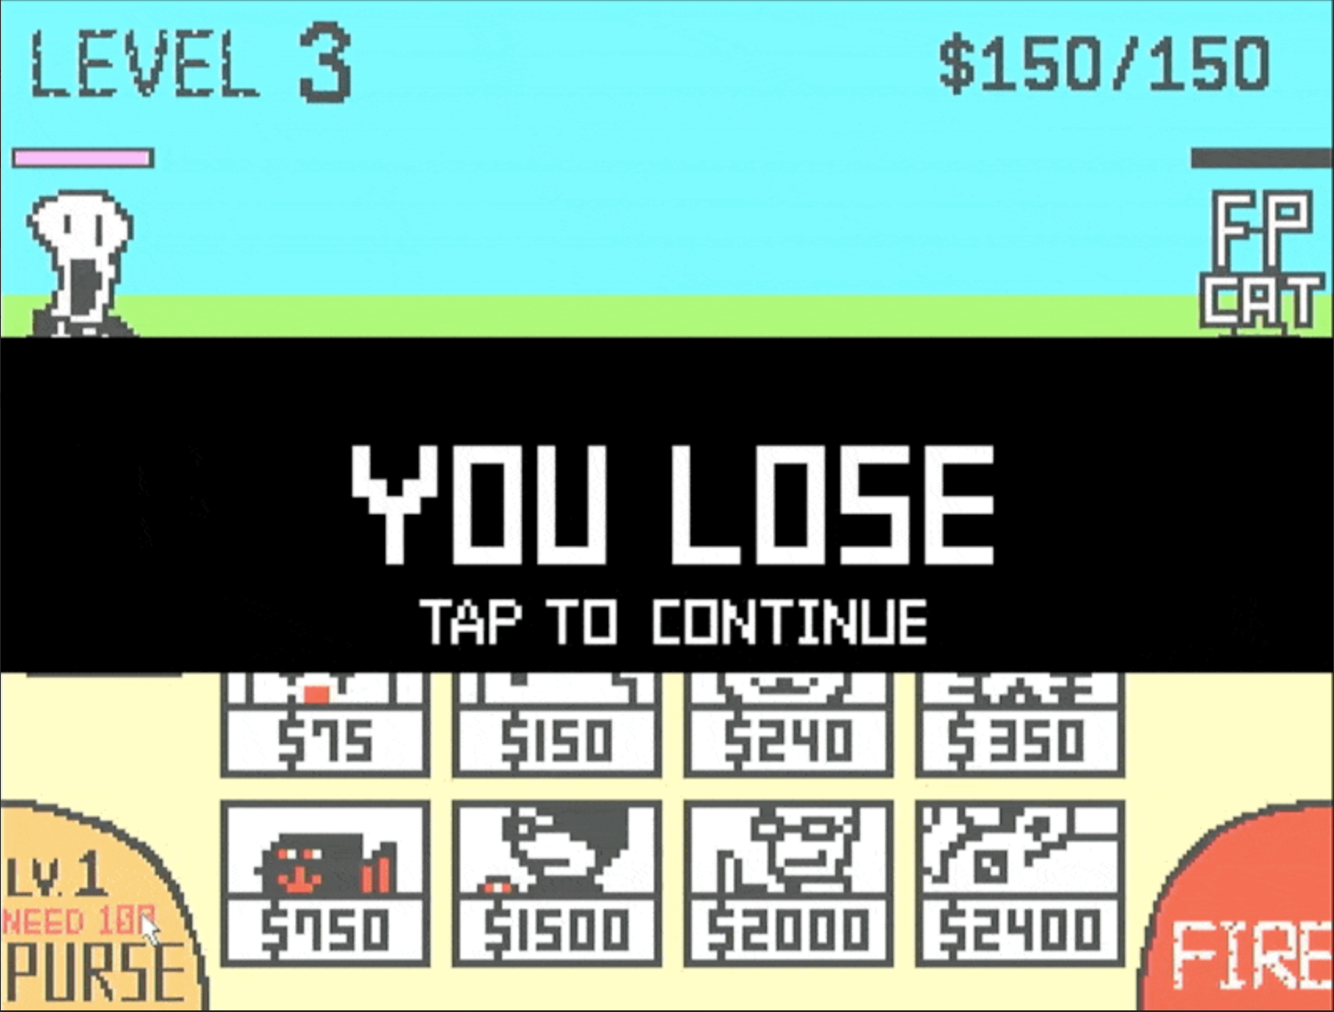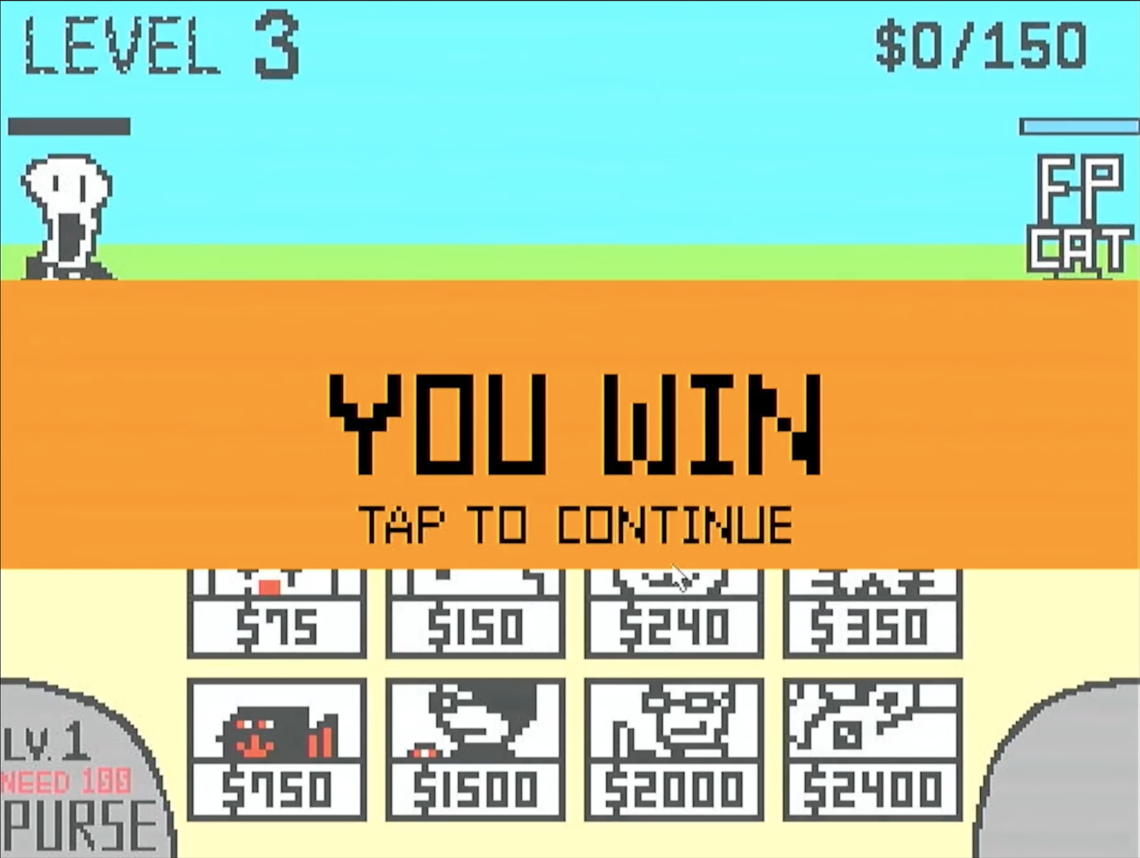For these two scenes, we overlay a horizontal bar on the game screen displaying the win/loss text. A flashing "Tap to Continue" prompt is added to inform players they can return to the Start Scene. Notably, in addition to the horizontal bar, we invert the colors of the final game screen behind the bar to emphasize it.

▲ Figure 2.4: Screenshot of Win/Lose Scene

# 3. Game Material Design

## 3.1 Static Object Design

We utilize IPs (Single-port RAM) to store 19 Static Objects, including:

* 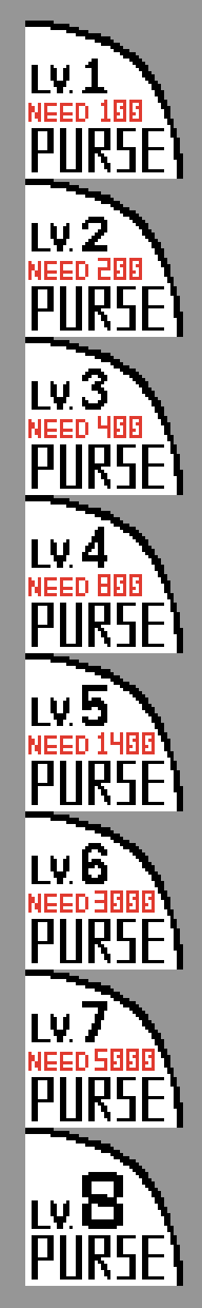Text Elements: 6 instances (mem_FPCAT, mem_LEVEL, mem_GAME_START, mem_YOU_WIN, mem_YOU_LOSE, mem_TAP_TO_CONTINUE)
* Numerical Elements: 2 instances (mem_Numbers, mem_Money_Max)
* Control Buttons: 2 instances (mem_Btn_Purse, mem_Btn_Fire)
* Generation Buttons: 8 instances (mem_Frame_...)
* 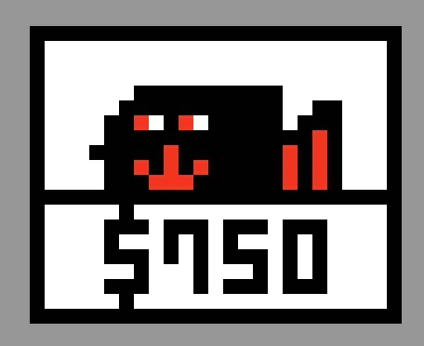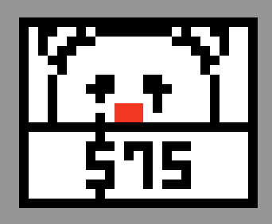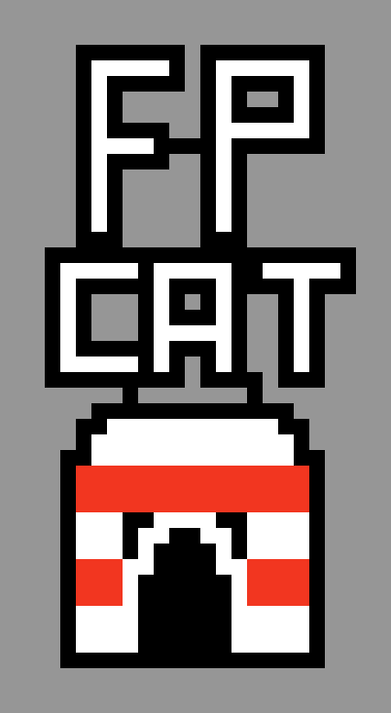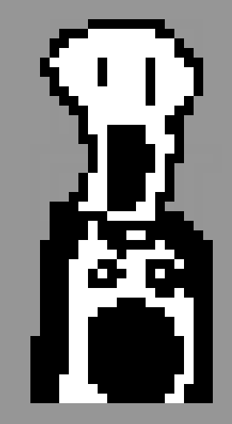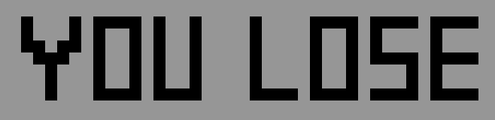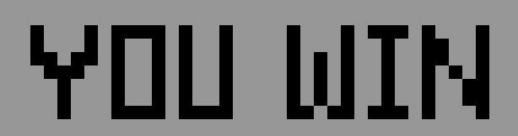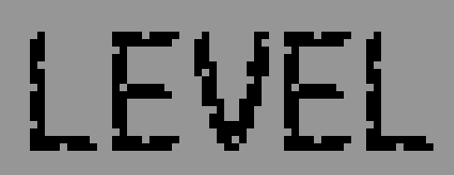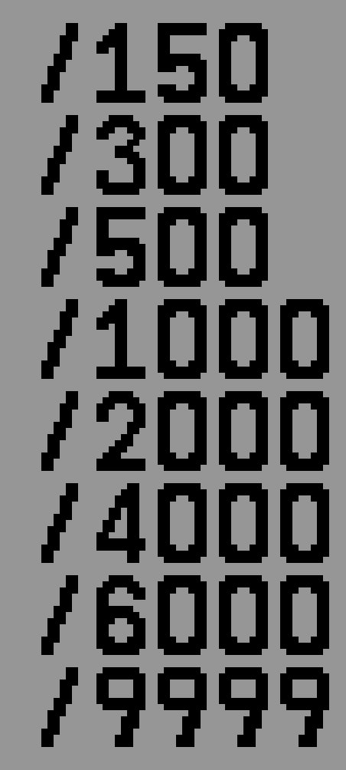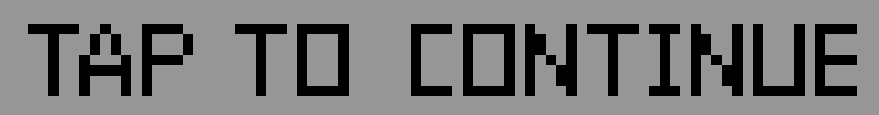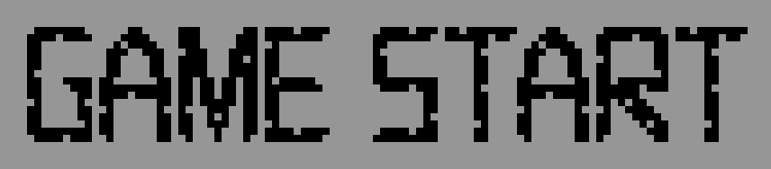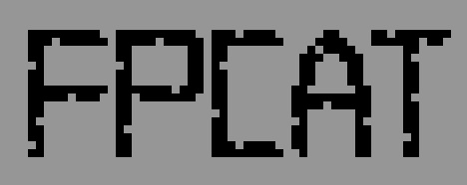Towers: 2 instances (mem_Tower_Cat, mem_Tower_Enemy)

5 more …

These elements were all designed by us and converted to **.coe** files using Python scripts (See Appendix A.2 for details) to serve as initial values for the RAM modules (these Static Objects' RAM values remain constant and are used solely for rendering purposes).

To optimize storage requirements, all .coe files storing images, including the characters mentioned in Chapter 3.2, were converted from PNG format using two methods. The first method, applied to single-color images, uses one bit per pixel to represent either colored or transparent states. The second method, used for three-color images such as characters, towers, and buttons, employs two bits per pixel to represent four states: black, white, red, and transparent. These approaches reduce the storage requirement from 12 bits per pixel (RGB) to either 1 or 2 bits per pixel.

To further address storage constraints, we initially reduced the number of frames per character. Some characters were assigned 4 frames, while others had 6 frames. However, this approach introduced complexity during rendering, as the address update logic had to account for both the character's state and the number of frames associated with each character. This increased the circuit's size and complexity. To simplify the rendering logic and make the system more general and maintainable, we decided to allocate 6 frames for every character(explained in detail in chapter 3.2), sacrificing some memory space in exchange for reduced circuit complexity and improved maintainability.

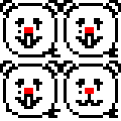 

▲ Figure 3.1.1: Original version ▲ Figure 3.1.2: Updated version

## 3.2 Character Design

We designed 6 images for each character, corresponding to five states: the first two represent the move state, the third to fifth correspond to atk0-1, atk2, and atk3, respectively, and the sixth represents the repel state. A decoder determines the image to access based on the character's state. Since character heights vary, another decoder retrieves width, height, and difference (used for range detection) based on character type. The picture size(height*width) is multiplied by the picture number to calculate the correct address, which is then used to render the character's state via the IP memory module.

While all characters in the game are original designs, some pay tribute to *Battle Cats*. For example, the enemy Black Bear is inspired by a classic character from the original game, known for its speed, high attack, and low health. In FPCATS, it’s less powerful to reduce game difficulty. Similarly, Bomb Cat is a nod to "Express Cat," sharing its high speed and attack but with slower attack speed.

We also added CS-themed characters like Elephant Cat (a classmate’s nickname), Hacker Cat, and CY Cat (named after a professor).

As for the roles of each character:

* **Joker Cat** serves as a mass-produced disposable unit with low health but very low cost.
* **Fish Cat** and **Trap Cat** are mass-produced tank units with high health and relatively low cost.
* **Jay Cat** is a long-range damage dealer with low health but decent range and attack power.
* **CY Cat** and **Hacker Cat** are versatile mid-range damage dealers. While their range isn't the longest, their attack power is very high.
* **Elephant Cat** is a tanky damage dealer. It has a longer range than mass-produced tanks, very high health, and decent attack power.

On the enemy side:

* **Killer Bird** is a standard small enemy, similar to goblins in an isekai setting.
* **White Bear** is a typical monster that often gives beginners a tough time.
* **Metal Duck** is a boss-level enemy.

Below are the stats for FPCATS characters:

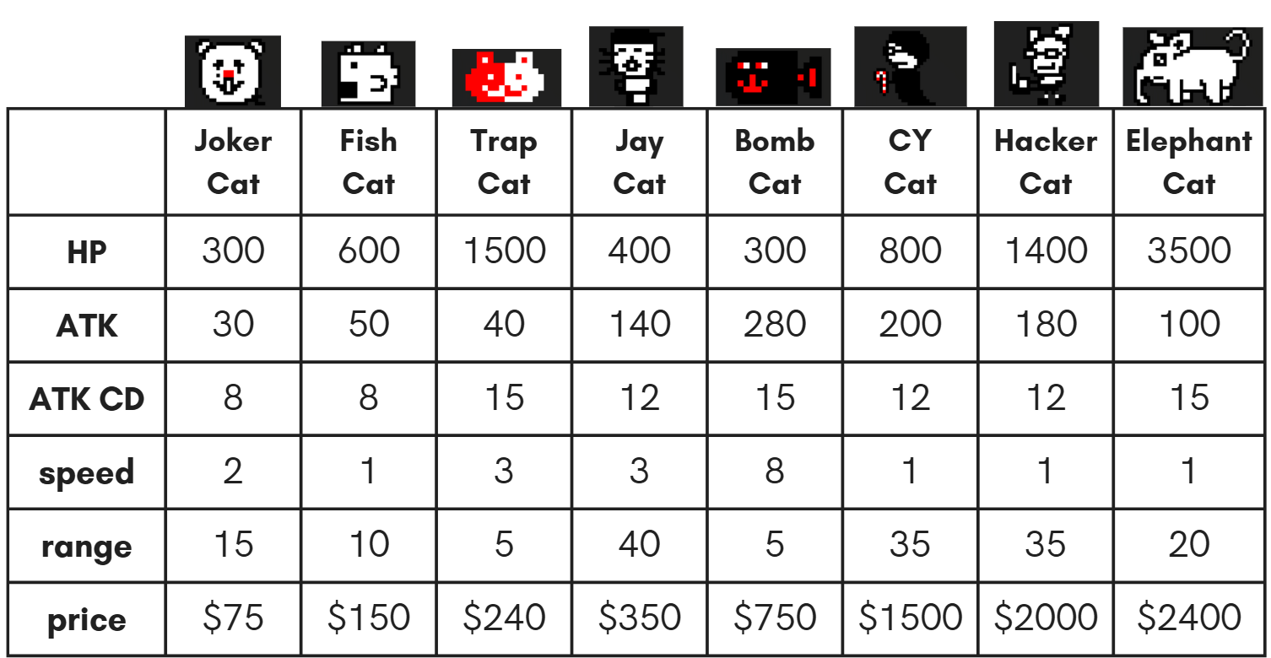

▲ Table 3.2.1: Army stats

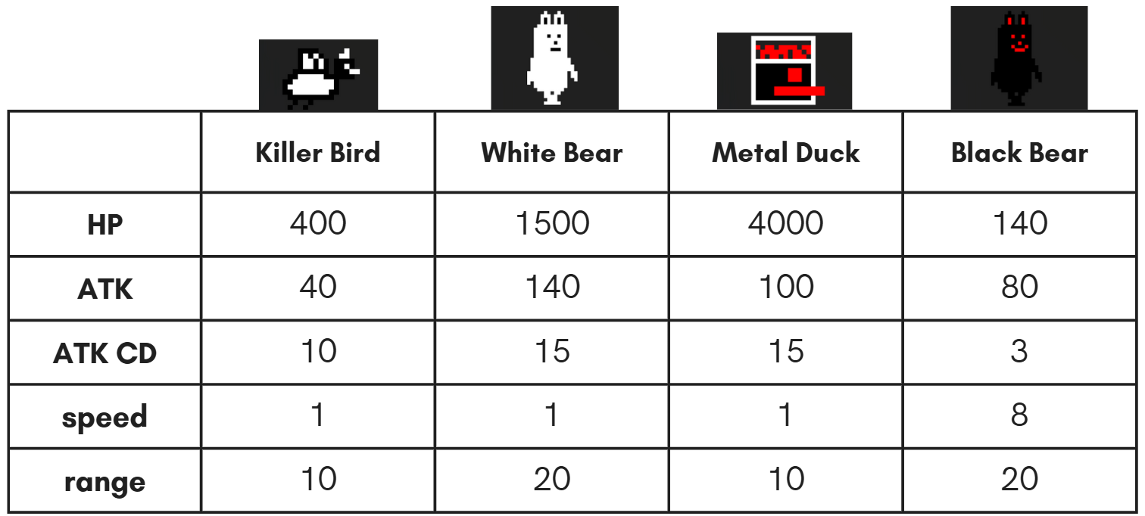

▲Table 3.2.2: Enemy stats

## 3.3 Stage Design

To summon enemies using the same mechanism as *Battle Cats*, we use IPs where each value contains a “timestamp” and an “enemy type.” In the Game Engine, we utilize an IP address pointer and a counter, game_cnt, to determine whether to summon an enemy. If game_cnt is greater than the timestamp value at the current IP address pointer and the enemy count is less than 8 (the maximum enemy limit), an enemy will be summoned, and the IP address pointer will move to the next address. Otherwise, enemy generation will stop.

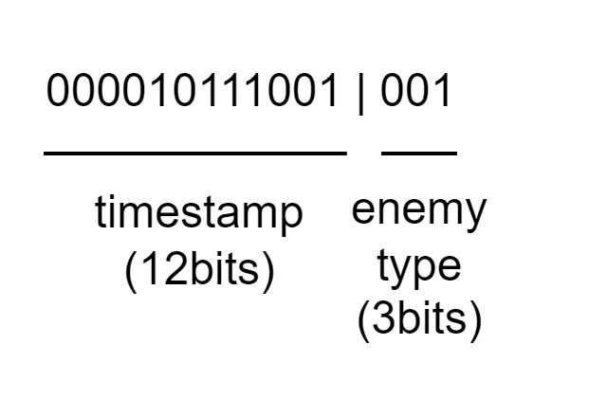

▲Figure 3.3.1: enemy queue IP protocol design

# 4. Game Engine

- Display Time & Blanking Time

## 4.1 Storage Protocols

## 4.2 Character FSM

## 4.3 Game State FSM

# 5. Graphics Rendering

## 5.1 Rendering Module Architecture

- scene change, tint technique

## 5.2 Layer Implementation

### 5.2.1 Statis Objects

### 5.2.2 Characters

# 

# 6. Conclusion

## 6.1 Gameplay Demonstration

## We will use a video to showcase our actual gameplay, providing a complete demonstration of the various features of our game. This is our video’s youtube link.

//TODO: video link

## 6.2 Comparison with Original Game

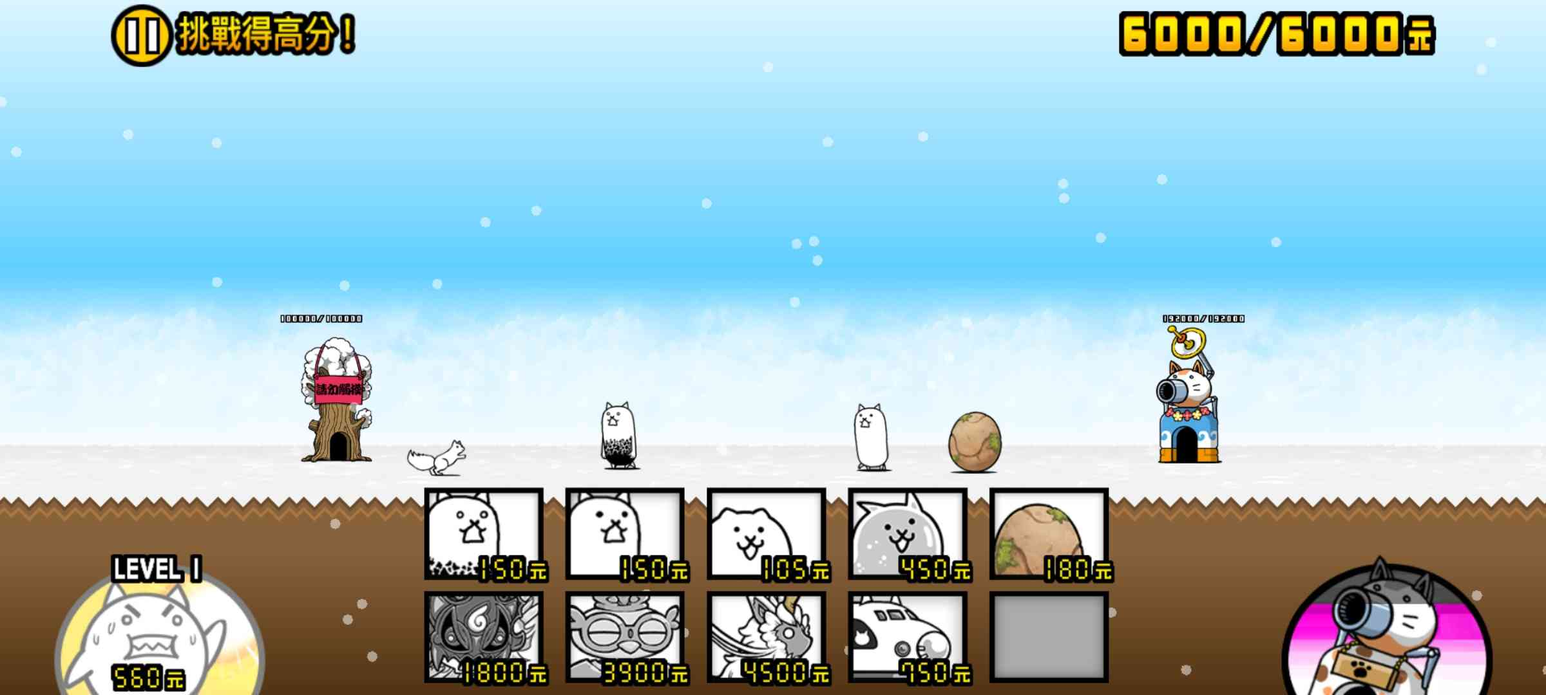 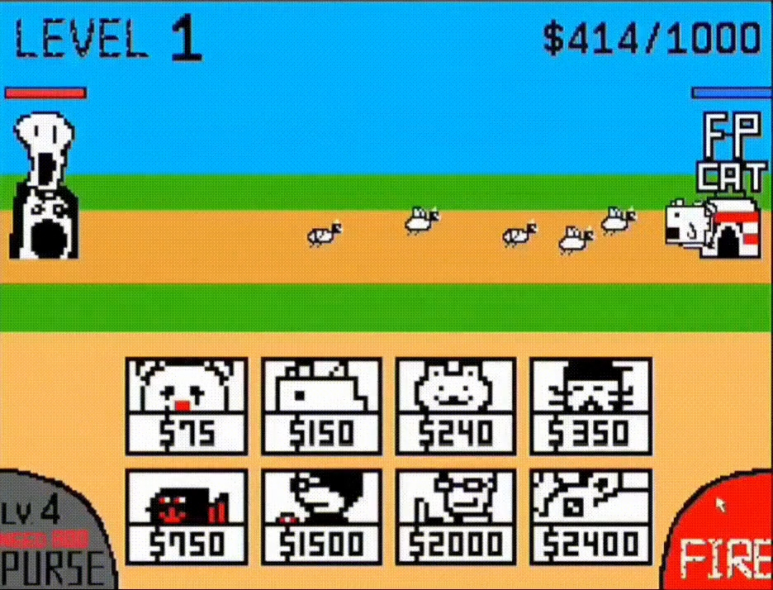

▲Figure 6.2.1: Just showing the screen layout of the original game and our game

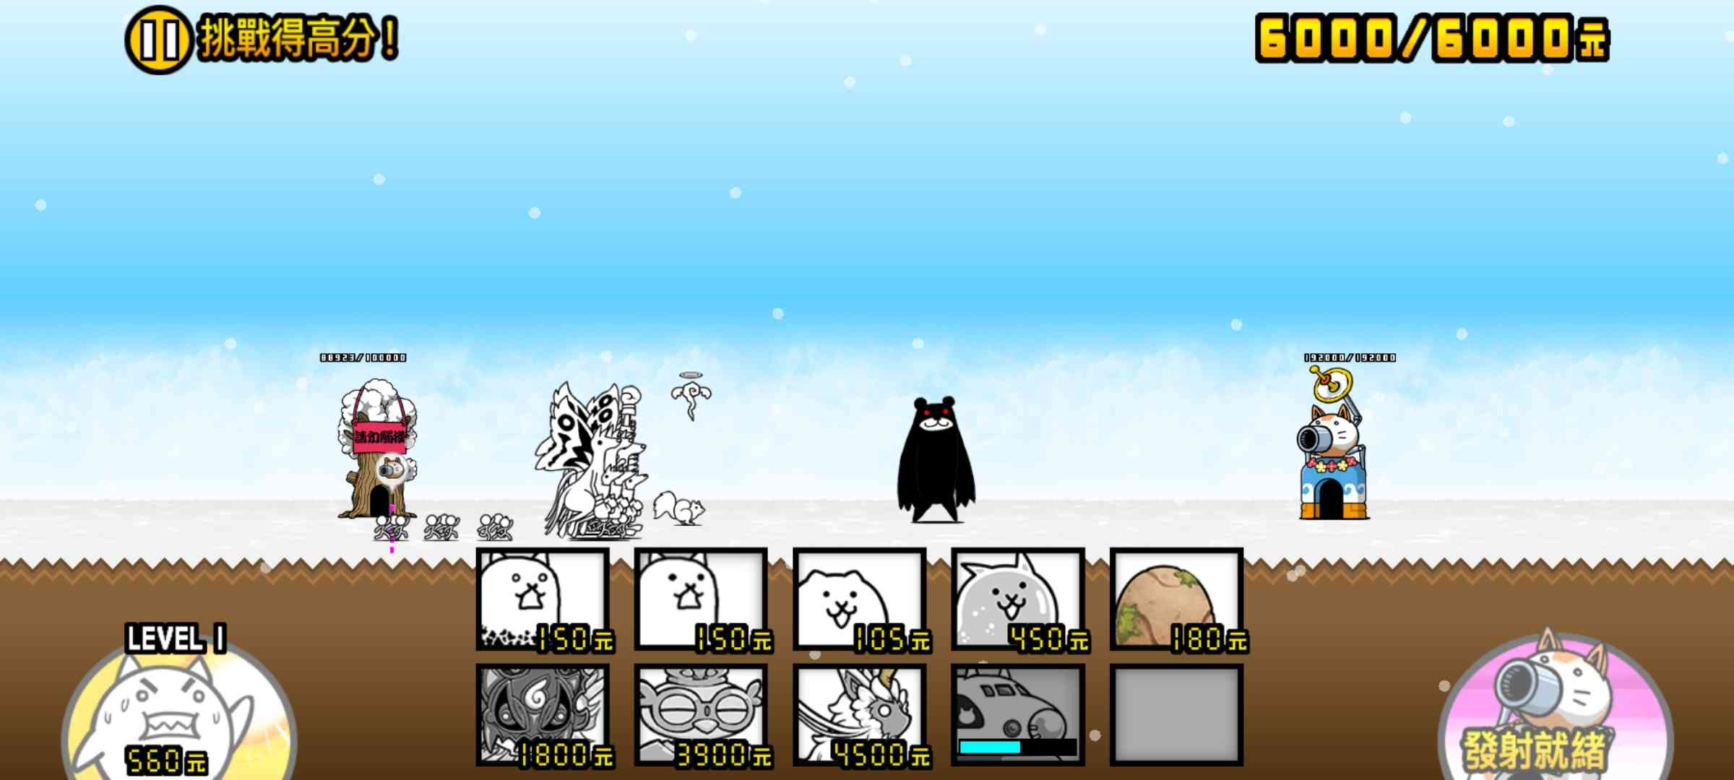 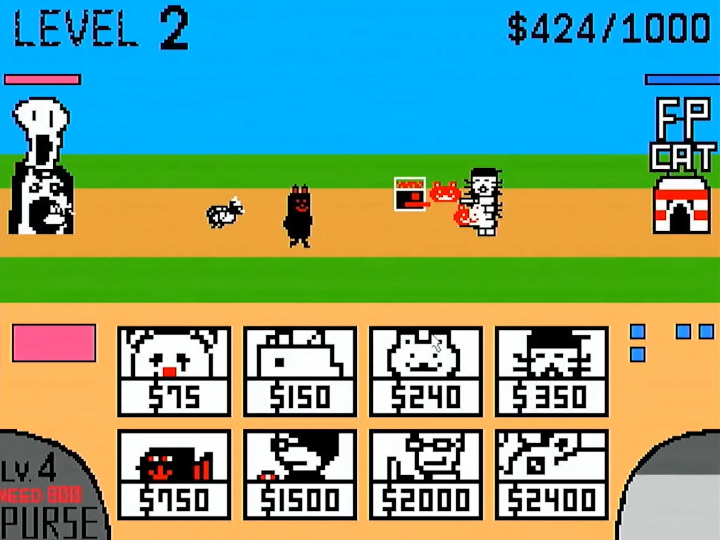

▲Figure 6.2.2: Black bear is coming!!! Watch out!!!

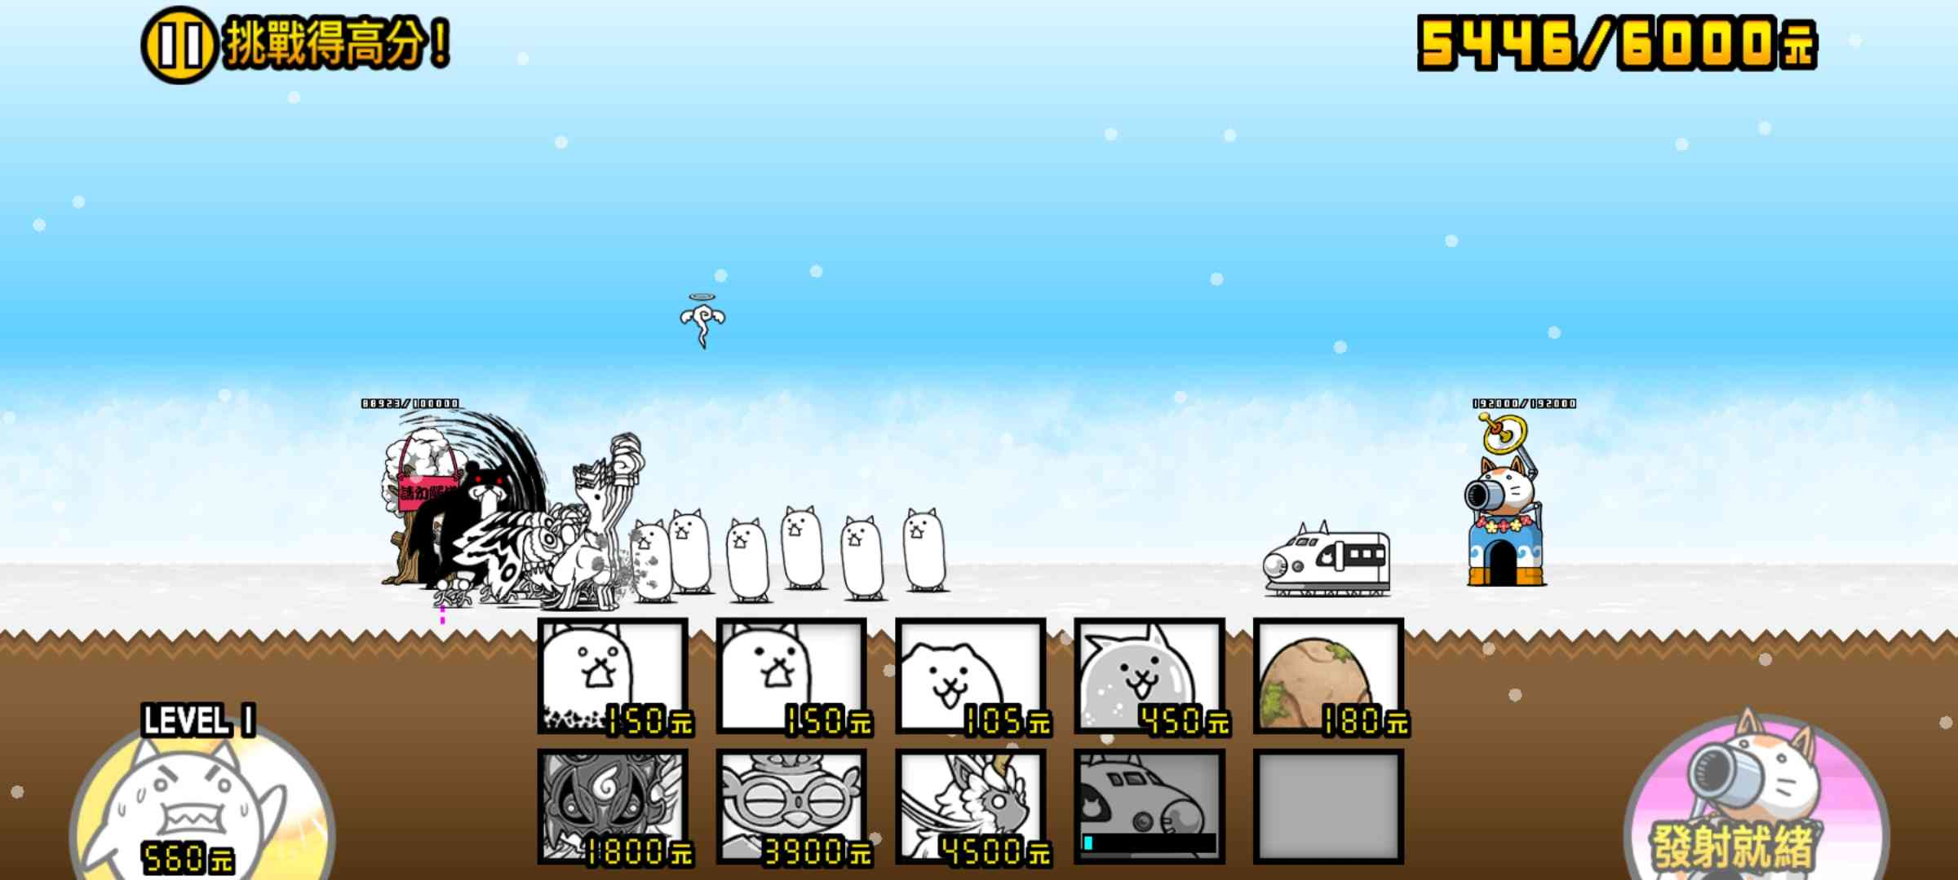 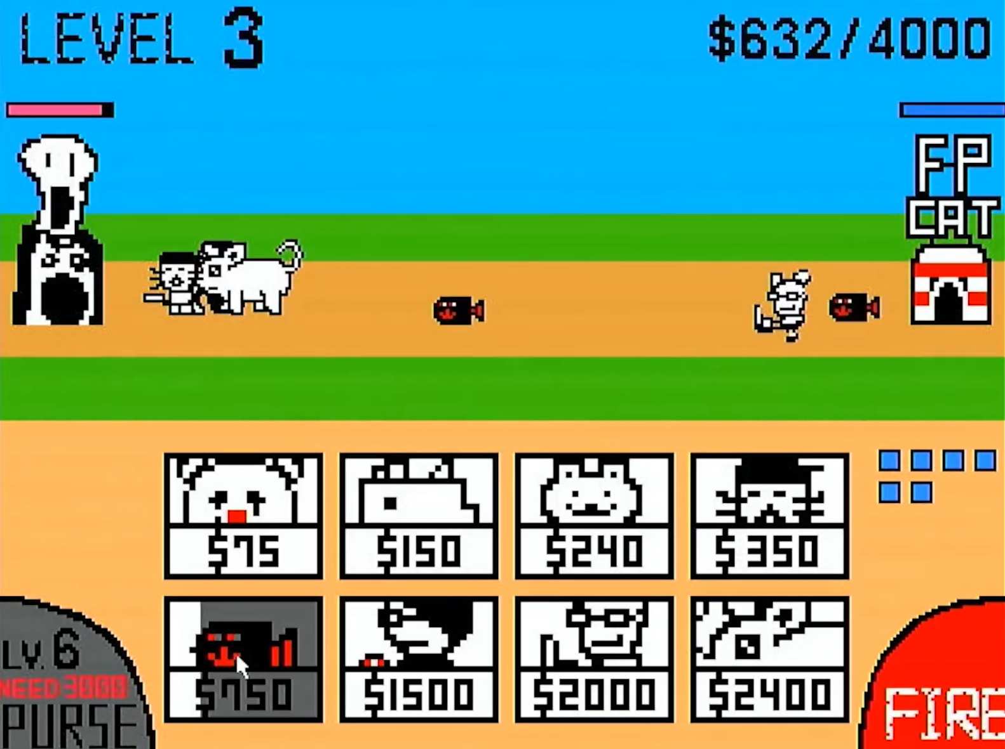

▲Figure 6.2.3: Don’t worry! Bomb Cat(Express Cat) is here.

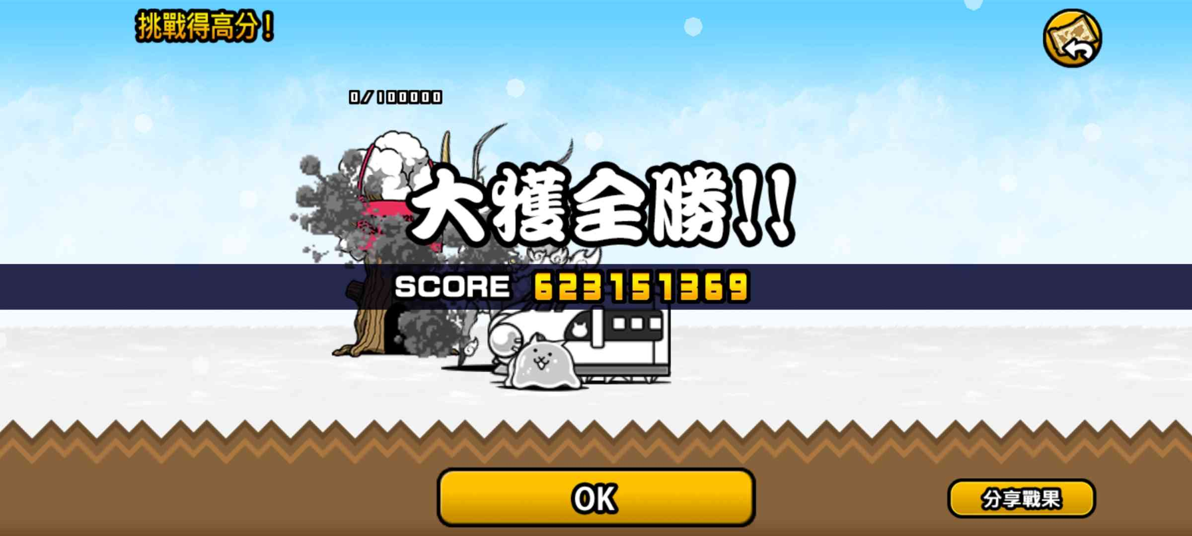 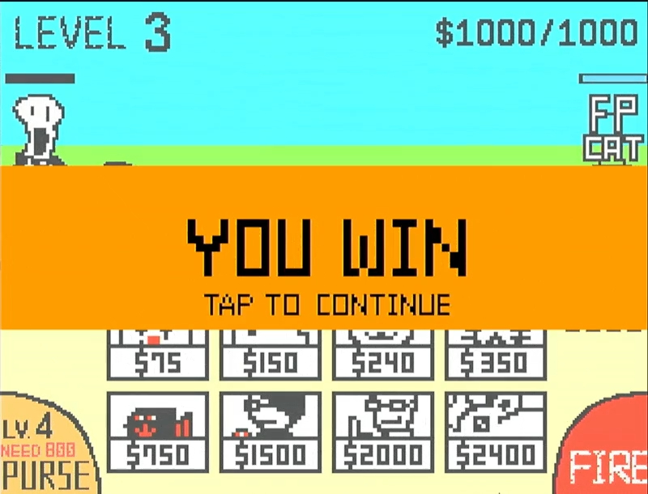

▲Figure 6.2.4: Hehehe! We are winning!

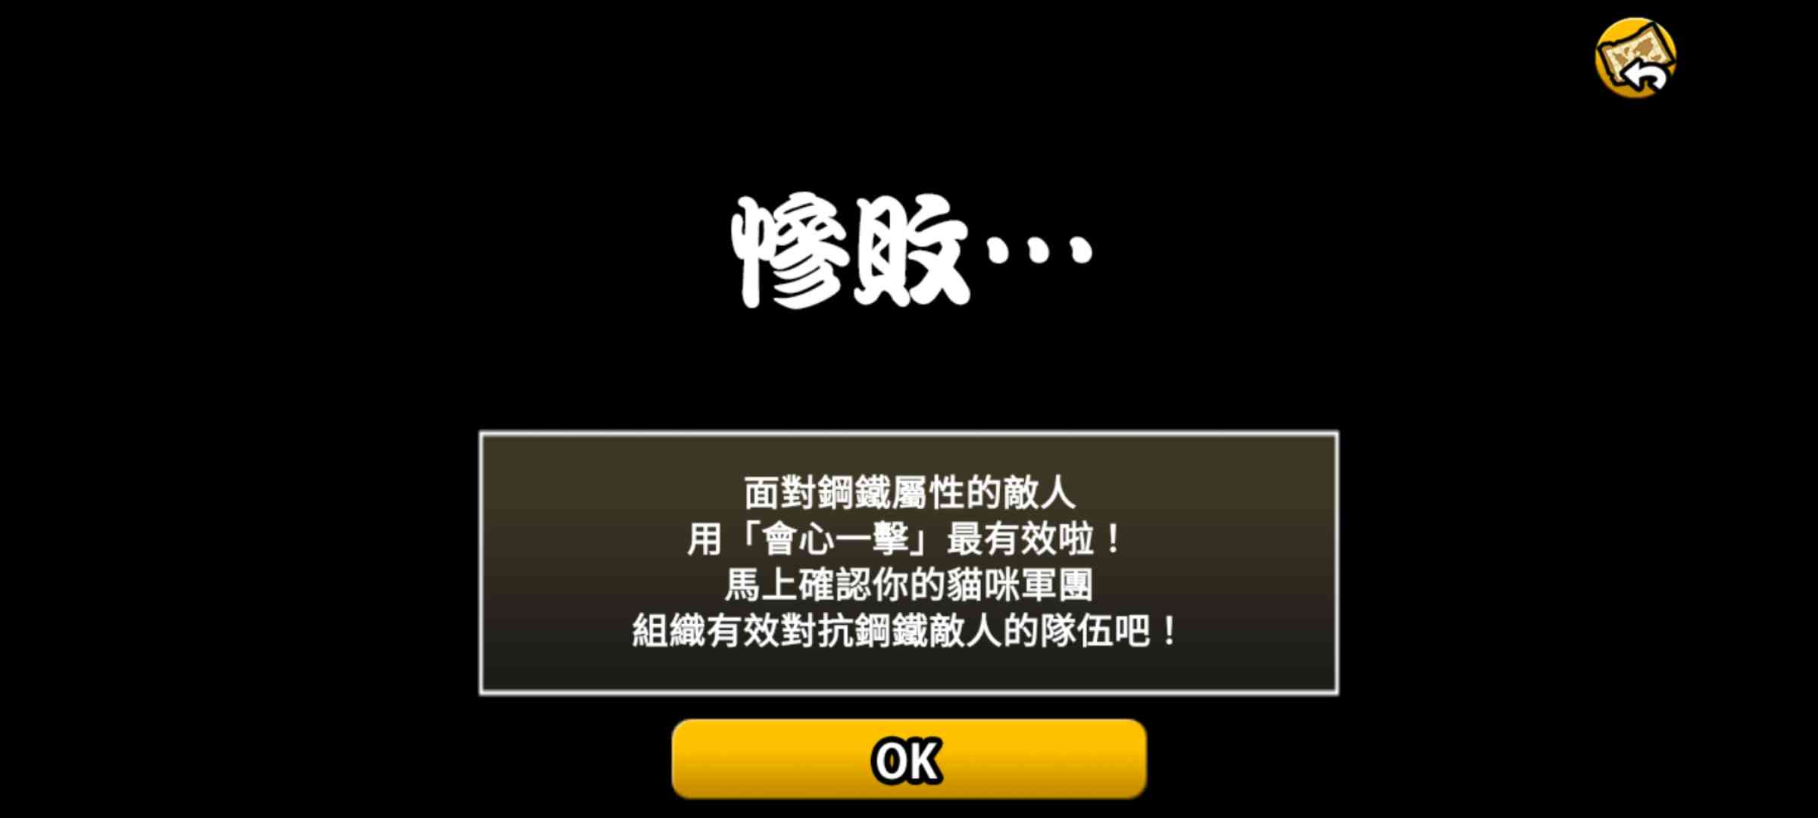 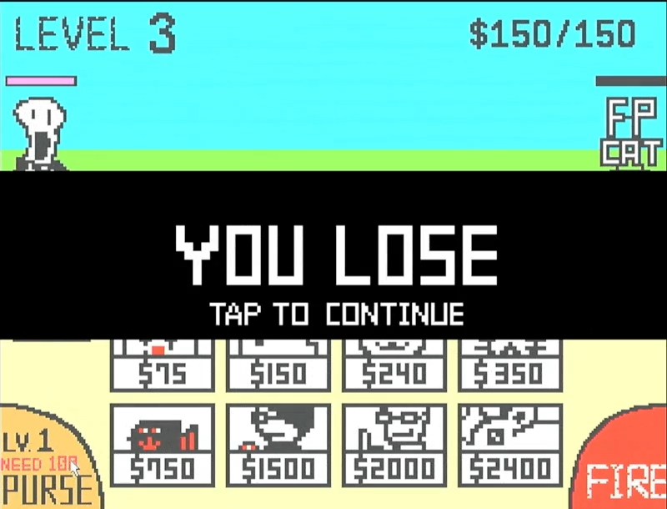

▲Figure 6.2.4: No…

## 6.3 What We Learned

# A. Appendix

## A.1 Contribution

## A.2 Python Tool - PNG to COE